Social and Professional Issues

Tutorial 4

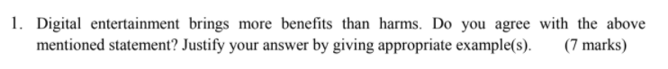

Agree

-Can gain more friends. For example playing video games can help players meet new friends and they chat with the people that have the same interest through the chat room.

- To improve coordination. For example when playing computer games can improve the hand and eye coordination of an individual because speed and alertness are required when playing games.

-Improves problem-solving skills. This is because some video games involve certain rules, so that the player has to think carefully before making any move to ensure that they stay within the required rules of that particular game.

|  |
| --- |
| Sample Answer:   * Social improvement. Digital entertainment can help to improve social interaction among user while engaging through online entertainment application. Playing video games can help players meet new friends and they chat with the people that have the same interest through the chatroom. For example, online game UNO allowed people with same interest interact in the chat box. The chatroom also allowed them to share their idea and other entertainment. * Digital entertainment plays an important role in spreading information, information can be spread within second using various entertainment channel. For example, information of Covid-19 pandemic could reach internet users through social media platform such as Twitter, Facebook and YouTube. * To express the stress. Digital entertainment can let people to express themselves from the stress. For example, playing computer games, listening music, watching movie or video and so on. People will feel broad if they keep doing their things in a looping. Playing the games to express the stress rather than drunk and smoke by harming themselves. |



I think is depends on the types of the game.If the games have the elements of gambling such as lucky draw,it may encourage gambling behaviour to the person who played the games.They will top up the real money to the games because they want to gain more rewards or benefits from the games which had elements of gambling and cause them addiction to gambling.

On the other hand,if the games don’t have the elements of gambling such as skill based games,it will not fuel addiction to gambling to the people.

|  |
| --- |
| Sample Answer: |



Patent : Is a right granted to an inventor that allows them to exclude others from making, using or selling their invention for 20years.

Patentable: Within the context of a national body of laws, invention is patentable if meets the relevant legal requirements to be granted a patent.

Patent Vs Copyright

Patent Protection

Protect idea/concept/design

E.g. technology, software design code, solution, mechanism, methods, framework, procedure, discovery, ways of doing thing, etc

Vs.

Copyright protection

Protect expression of idea

E.g. musical work (song, lyric, melody, OST, album, music play), dramatic work (movie, music video, animation/cartoon, TV reality show), literacy work (book, novel, fiction, poem), art work (e.g. drawing, painting, sculpture), etc

Condition of patentability: To be protected by a patent, an invention must be **novel**(must not be known before filing the application), **inventive**(must differ from what is already known), have **industrial applicability**(able to used in any kind of industry, commerce or in agriculture) and be **lawful**(inventions whose commercial use would violate public order or morality are not patentable include those would cause damage to environment or risk the life or health of plants, animals or human being.).

For Malaysia context, filled up the patent registration/application form and file under MYIPO ([www.myipo.gov.my](http://www.myipo.gov.my)) → malaysia intellectual property corporation /Intellectual Property Corporation of Malaysia

|  |
| --- |
|  |



**What is a copyright?**

Refers to a collection of rights. These rights are automatically granted to those who create original works (such as literary works, songs, movies, or software). Through copyright, owners can choose the way to make their copyright-protected works public.

5 exclusive rights under copyright:

- Reproduction (for prevent the people to reproduce your works)

- Distribution (distribution your work in anyway)

- Public Display (display your pictorial work)

- Public Performance (performs your world at any places)

- Production of derivative works

The foundation of copyright protection comes directly from the US Constitution. Copyright law aims to enrich the public by acquiring creative works, and importantly, it does not require creators to provide their copyrighted works. However, there are some restrictions on the rights granted to copyright owners.

**How is a copyright obtained?**

There are two ways to obtain copyright: automatic acquisition and registration acquisition.

In Malaysia, the creator of the original work automatically owns the rights to the work. There is almost no need to register. However, it is recommended that you register, as this will help establish specific evidence and timelines of ownership and ultimately help realize the rights.If the representative of the original creator applies for copyright in Malaysia, additional documents and related fees are required.

For Malaysia context, filled up the copyright declaration form and file under MYIPO ([www.myipo.gov.my](http://www.myipo.gov.my)) → malaysia intellectual property corporation /ntellectual Property Corporation of Malaysia

Proof of originality

In practice, authors have resorted to a number of ways to preserve their interests/work originality. They may have:

• Deposited a copy of their work with their lawyers or in a depository

• Made a declaration/notification of their IP work at MYIPO stating the facts of ownership and the date of creation

***As a conclusion--> Copyright is secured automatically when a work is created. No publication, registration or other action in the Copyright Office is required to secure copyright. However, definite advantages to registration, including the ability to sue for infringement.

|  |
| --- |
|  |



Trademarks

* A word, symbol, picture, sound, or color used by a business to identify goods.
* Used to establish “brand name”
* Branding allows consumers to have more confidence in the quality of the products they purchase
* One way to prevent a trademark from becoming a generic trademark is to use advertising to ensure that the trademark name is used as an adjective, not a noun or verb.

How is a trademark obtained

* Trademark rights are acquired by being the first to use the mark in commerce. Under the Trademark Law Revision Act of 1998 a trademark owner can apply for registration prior to using the mark, based upon the owner's bona fide intent to use (ITU) the mark. In Malaysia, trademark rights can be gained by registration. To register for trademark rights, one is required to submit the relevant application form (Form TM5) to the Intellectual Property Corporation of Malaysia (MyIPO).

|  |
| --- |
|  |

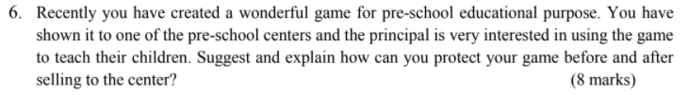

**Before selling:**

* **Register a patent** to prevent the center from making, using or selling the invention of the game for 20 years. It is a public document which provides a detailed description of the invention of the game and also provides the owner with exclusive rights to the game.
* Register a trademark for the game title and also logo to have maximum protection against clones. Therefore, others can be found in trademark violation to prevent their games to have a confusingly or similar title.

**After selling:**

* **Register copyright** protection to get an original work to be protected under the five exclusive rights, namely…….. This is to ensure that the original work will not copy but anyone unless permission is given by the author grants to the person.
* **Inform the pre-school management** that this game is under the protection of patent and copyright. They should promise not to sell to others or let others copy without permission.
* Public also should be informed that this game is copyrighted and patent protected.

-endorsed trademark registration for the games---> e.g. game logo, game slogan, game company name that launched this popular name….

|  |
| --- |
|  |



Yes. Because the software patent can be used to **prevent others from utilizing a certain algorithm without permission** or to **prevent others from creating software programs that perform patent-protected functions**. For example, after Company A applies for a patent and obtains a patent right, other companies may not implement the patented technology without permission, so the applicant can occupy the market space of new technology and its products alone and obtain corresponding benefits. On the contrary, if a new technology is not patented, the above benefits cannot be obtained and anyone can use it.

|  |
| --- |
|  |



No, it is because they are both selling different products and this is allowed. A registered trademark can prevent others from using the same trademark only for those goods or services they sell. For example, selling shoes using a registered trademark, others have no right to sell the shoes with the same trademark.

|  |
| --- |
|  |

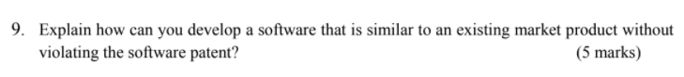

**(i) Clean Room Development** - Software developing team can be divided into two groups.

The first group will examine competitor’s product and produce technical specification for the new software product.

The second group will be isolated from the first group and develop, code and debug the new software solely based on the technical specification produced by the first group.

(ii) Negotiate with the company that owning the s/w patent right so that certain amount of profit/charge/benefit to be paid to them in order to allow you to continue to use such patent to create new derivative work out of it.

(iii) Use different implementation (programming language or style) to implement/deliver the software.

(iv) Provide different or extra features

(v) Check to see (e.g. patent search) whether such involved software patent expiration date before you use/refer to it to create your work/invention.

|  |
| --- |
|  |

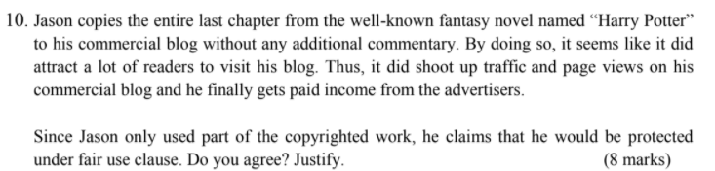

* No, I disagree. Jason will not be protected under fair use clause because Jason used that to gets paid income.

To consider fair use, we will look into the 4 factors:

(i)Purpose of use

If Jason used as education purpose, Jason will be protected by under fair use clause but Jason used for income. Hence, in this case, it is against fair use.

(ii) nature of work [fiction Vs non-fiction (factual)], [published work Vs. unpublished work]

If Harry Potter’s book is non-fiction, it will be more permissible under the fair use clause. but the Harry Potter book is fiction. Hence, It is against the fair use.

(iii) The amount of work/portion of work taken

Jason also copied the entire last chapter from the novel named “Harry Potter” without permission from the writer and upload it to this commercial blog. If the amount of portion taken is large, then it will be less permissible under the fair use.

(iv) The effect the use upon the potential market

This might affect the number of selling of the novel named “Harry Potter”. Hence,inthis case, it is against the fair use.

In conclusion, in this case, it is against the fair use.

|  |
| --- |
|  |